USKUDAR UNIVERSITY

FACULTY / INSTITUTE OF ENGINEERING AND NATURAL SCIENCES

COMPUTER ENGINEERING DEPARTMENT / PROGRAM

2020-2021 FALL

FINAL PROJECT REPORT

STUDENT ID: 170201002

NAME LASTNAME: TOLGA BERK ORDANUÇ

PROJECT TITLE: Analyzing Famous Iris Dataset

1. INTRODUCTION

I chose maybe the most famous dataset for this project which is iris dataset. It is donated to the community in 1988 and collected/created by R.A. Fisher.

It consists of 150 samples for iris flower. It is equally divided to 3 types of iris plant (Iris Setosa ,Iris Versicolour, Iris Virginica). It has 4 features for every plant in the set.

The task is predicting which class is the plant based on those 4 features.

1. MATERIALS AND METHODS

Dataset: <http://archive.ics.uci.edu/ml/datasets/Iris>

dataset has four features for each plant. Which are length and width of the sepals and petals.

I used Rapid Miner to analyze and make predictions about the data. Because it is widely used in the industry and has a free tier. It allows us to apply many data analyzing, cleaning and machine learning methods. And it is really easy to use, at the same time effective.

It is written in java and has been on the market for 16 years. Gained up a lot of trust from specialists. The development of the project started in 2001 at the Technical University of Dortmund under the name of YALE (Yet Another Learning Environment). In 2006 software has been bought by a company named Rapid-I. Then in 2007 the name changed from Yale to Rapid Miner. As of today, machine learning community and Data scientists are using it heavily on their projects and prototyping.

I chose TensorFlow.js for my code library. Machine learning and Data analytics are kind of in the python’s area. And I could choose pytorch or sklearn and numpy of course but I wanted to discover the possibilities which can be accomplished by a simple scripting language(!) like javascript. TensorFlow.js is a library which gets it power from WebGL, which is a interface for browsers to communicate with OpenGL. Which means we can use graphics card. Hence, it is hardware accelerated and has potential to handle complex matrix computations. Which is more than enough for a project like this. It is developed and managed by Google and nevertheless it is open source. Has a great documentation. Before it was picked up by google the projects name was deeplearning.js and had no server-side support it could only use browser environment to run code on the GPU. But after it got merged into Google’s big TensorFlow Library the name changed to TensorFlow.js and the team started to work on a version which can be run on Node.JS which is a server-side runtime for JavaScript. But GPU support for Node.JS environment is still limited to Linux only due to Google’s only support for CUDA. CUDA is kind of an API to talk to NVDIA’s graphics card but it is out of scope. And shortly that is why I chose to run it on a browser environment. And I used the advantage of TypeScript which is a superset of JavaScript which has type-checking and compile time error reporting features. It is basically the missing part of JavaScript. I used webpack to bundle and optimize my code into a single JS file. By optimizing I mean minifying because that is all you can get with JavaScript.

For the graphs and plots I used Plotly.JS. Plotly.JS is a library for drawing graphs and plots with SVG in browser. It is almost the same as plotly.py in python but it does not pop windows, but it draws to browsers html tree as SVG format. It is developed by the same team as Plotly.py.

For shuffling I used an algorithm called Fisher-Yates shuffle. Which turns out to be a little famous. Because it has a complexity of O(n). Unlike picking random indices in an array and putting them in some random index again or copying the array and placing them in different indices, it uses a very intelligent way to not miss, the not chosen ones without even copying the array. It decreases the indices that we can randomly select in every iteration, and performs swapping only one time per each element in the array. Hence O(n). Here is a really good visualization for the algorithm:

[Fisher-Yates Shuffle Visualization](https://bost.ocks.org/mike/shuffle/)

In TensorFlow.js we have Layers API. And it allows us to easly configure an Artificial neural network model. Neural networks are our effort to model the human brain in computer environment. The basic form of neural network is feed forward neural network. It consists of an input layer, couple of hidden layers and an output layer, these layers are formed with nodes called neurons. The neurons are connected to every node on the next layer and those connections has values. Which are called weights. These weights are basically multipliers for their impact on the decision that our neural network is working on. So, with TensorFlow.js s layers API I was able to put up a neural network width 4 input nodes 1 hidden layer and 3 output nodes. Input layer corresponds to features and output layer indicates the species in the iris dataset. And it would give me the probability of the sample data belongs to which class.

1. TOOL

Here is the steps to configure Rapid Miner and get results for this dataset.

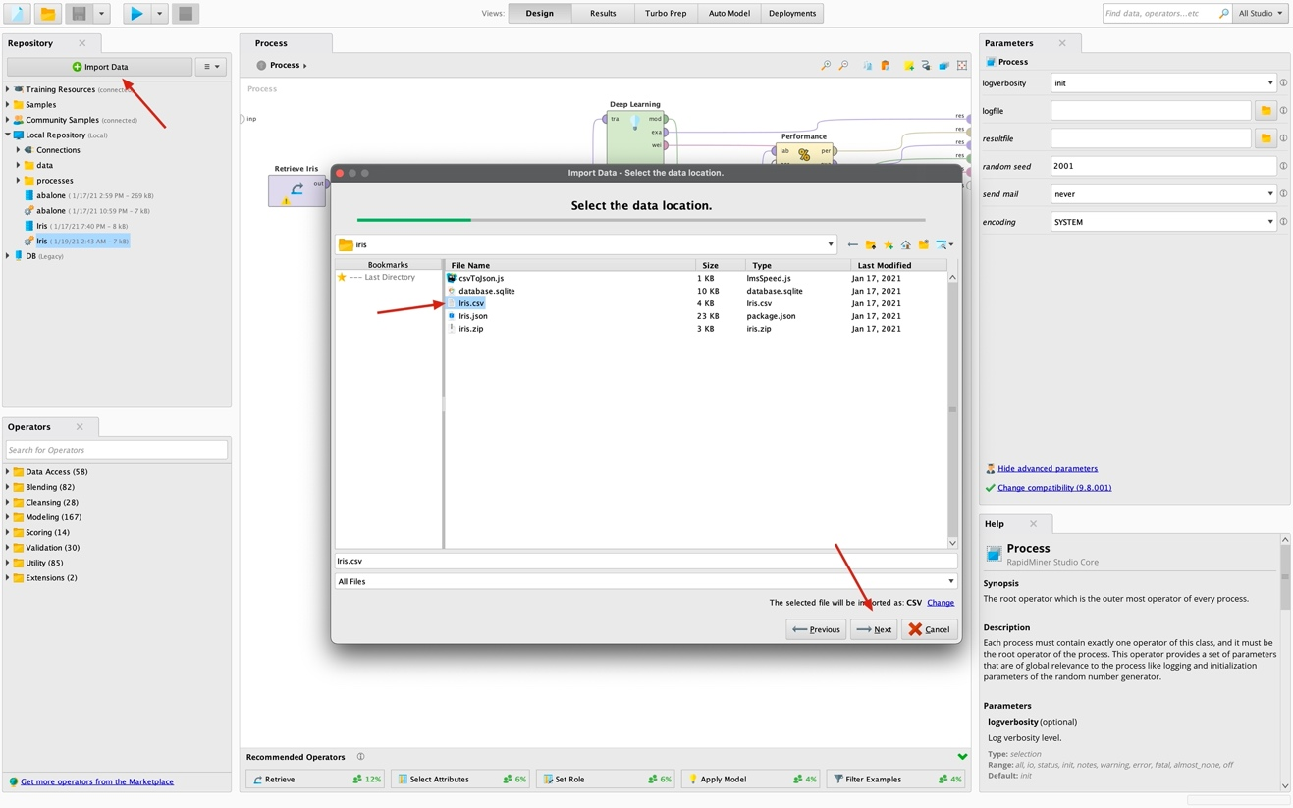First we import iris dataset to rapid miner as shown.

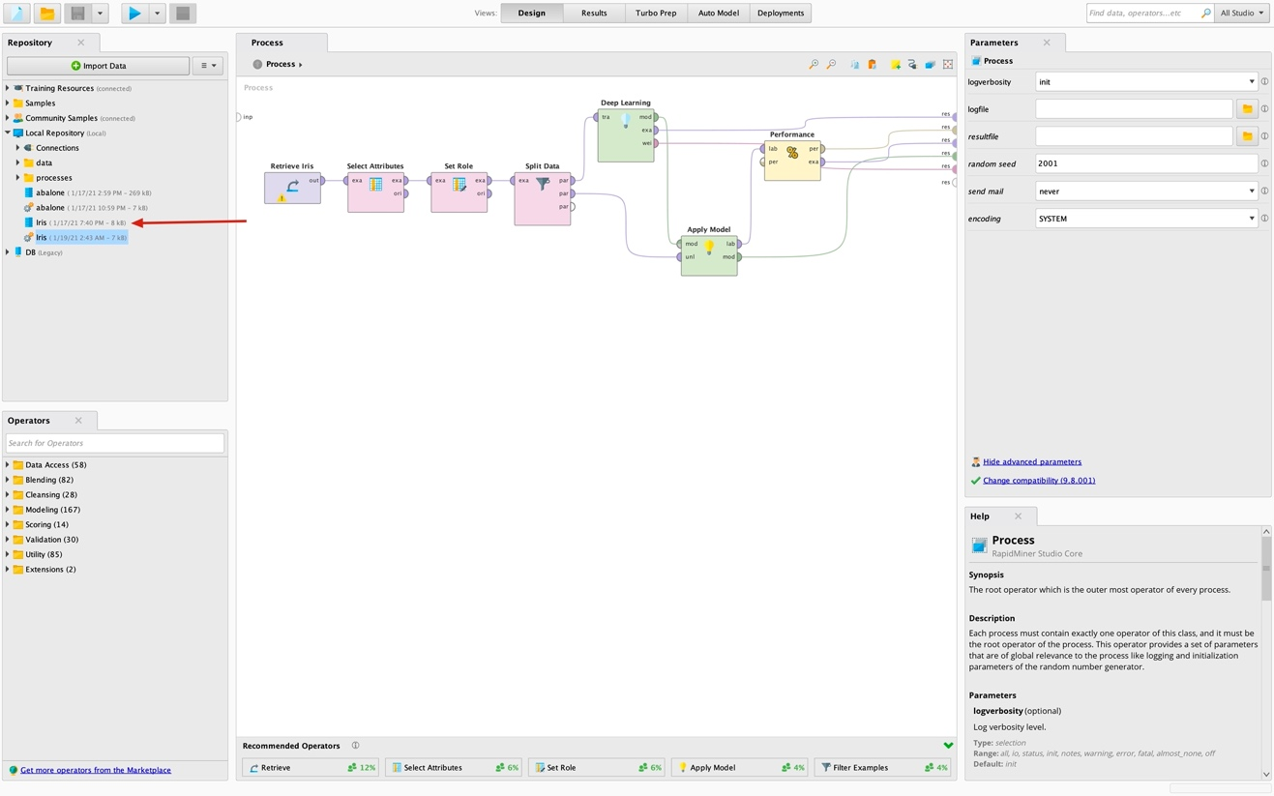Here is our imported dataset. I just dragged it to process section.

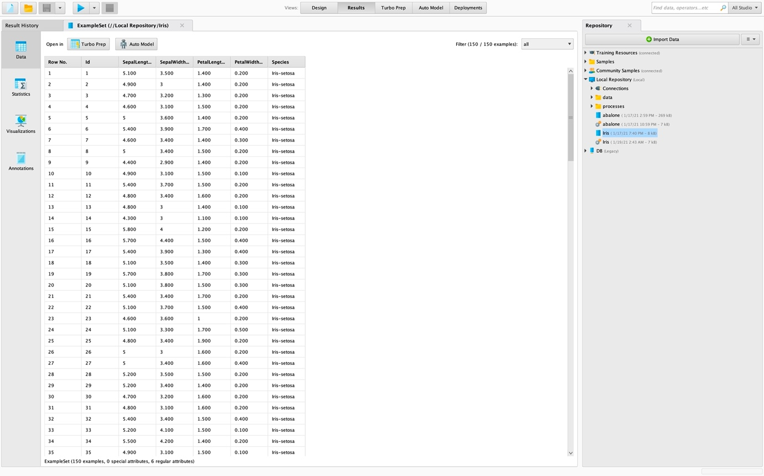After, I dragged it I connected the output port of the node to one of the res ports on the most right. After, I ran the process with the button on up left corner, I was able to see the dataset.

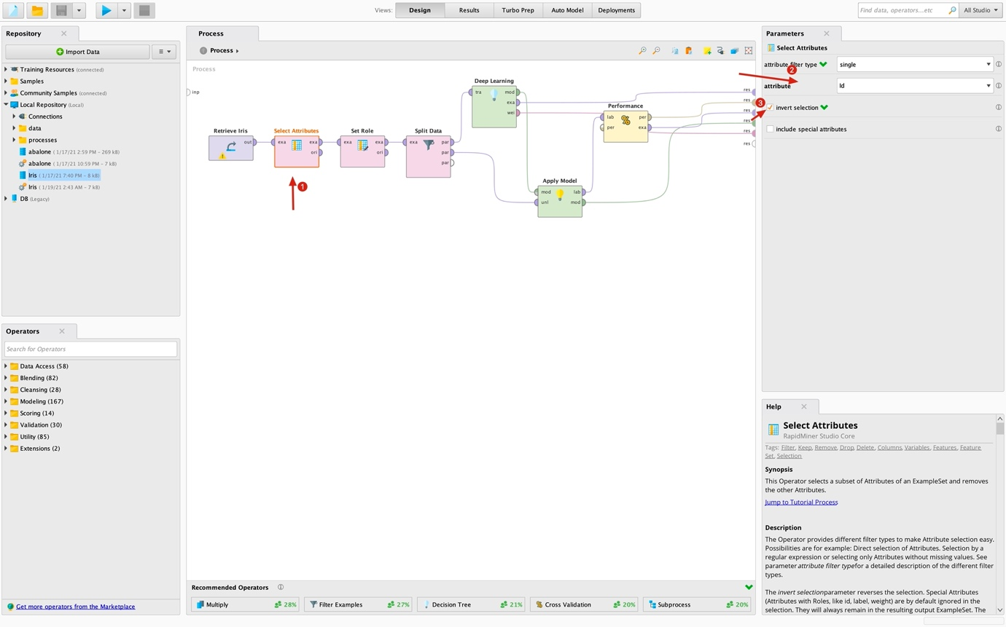After that I got rid of the id property with select attributes operator.

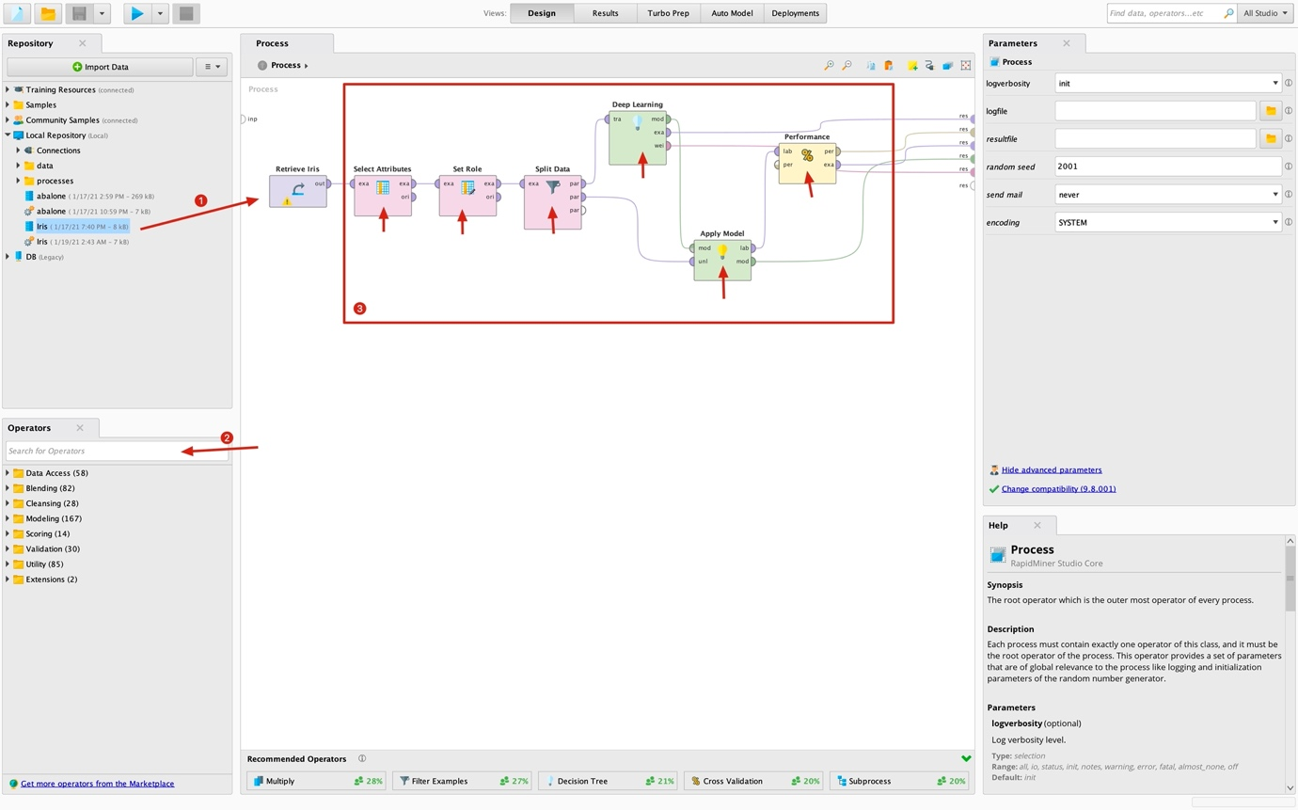In the process section there are nodes which I put in a certain order. Those nodes which are indicated in red square came from the operators section as shown with the #2 arrow. Only the first one came from the repository section because it is our dataset.

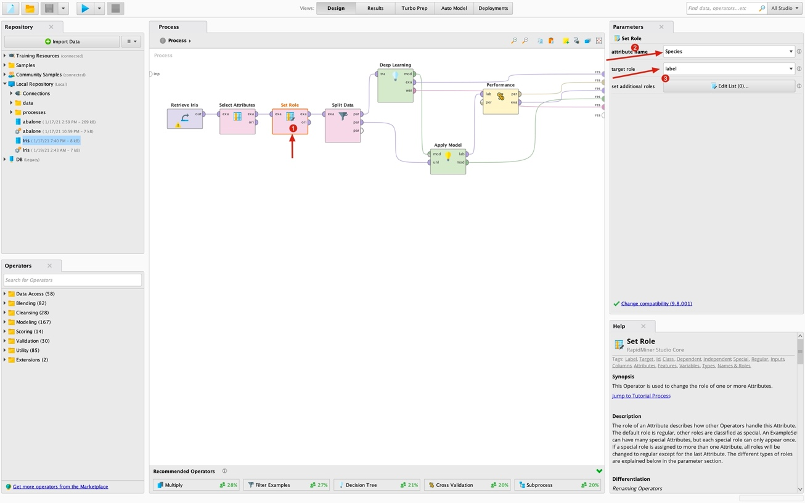Then we need to specify a label property in our dataset in order to rapid miners deep learning node to operate.

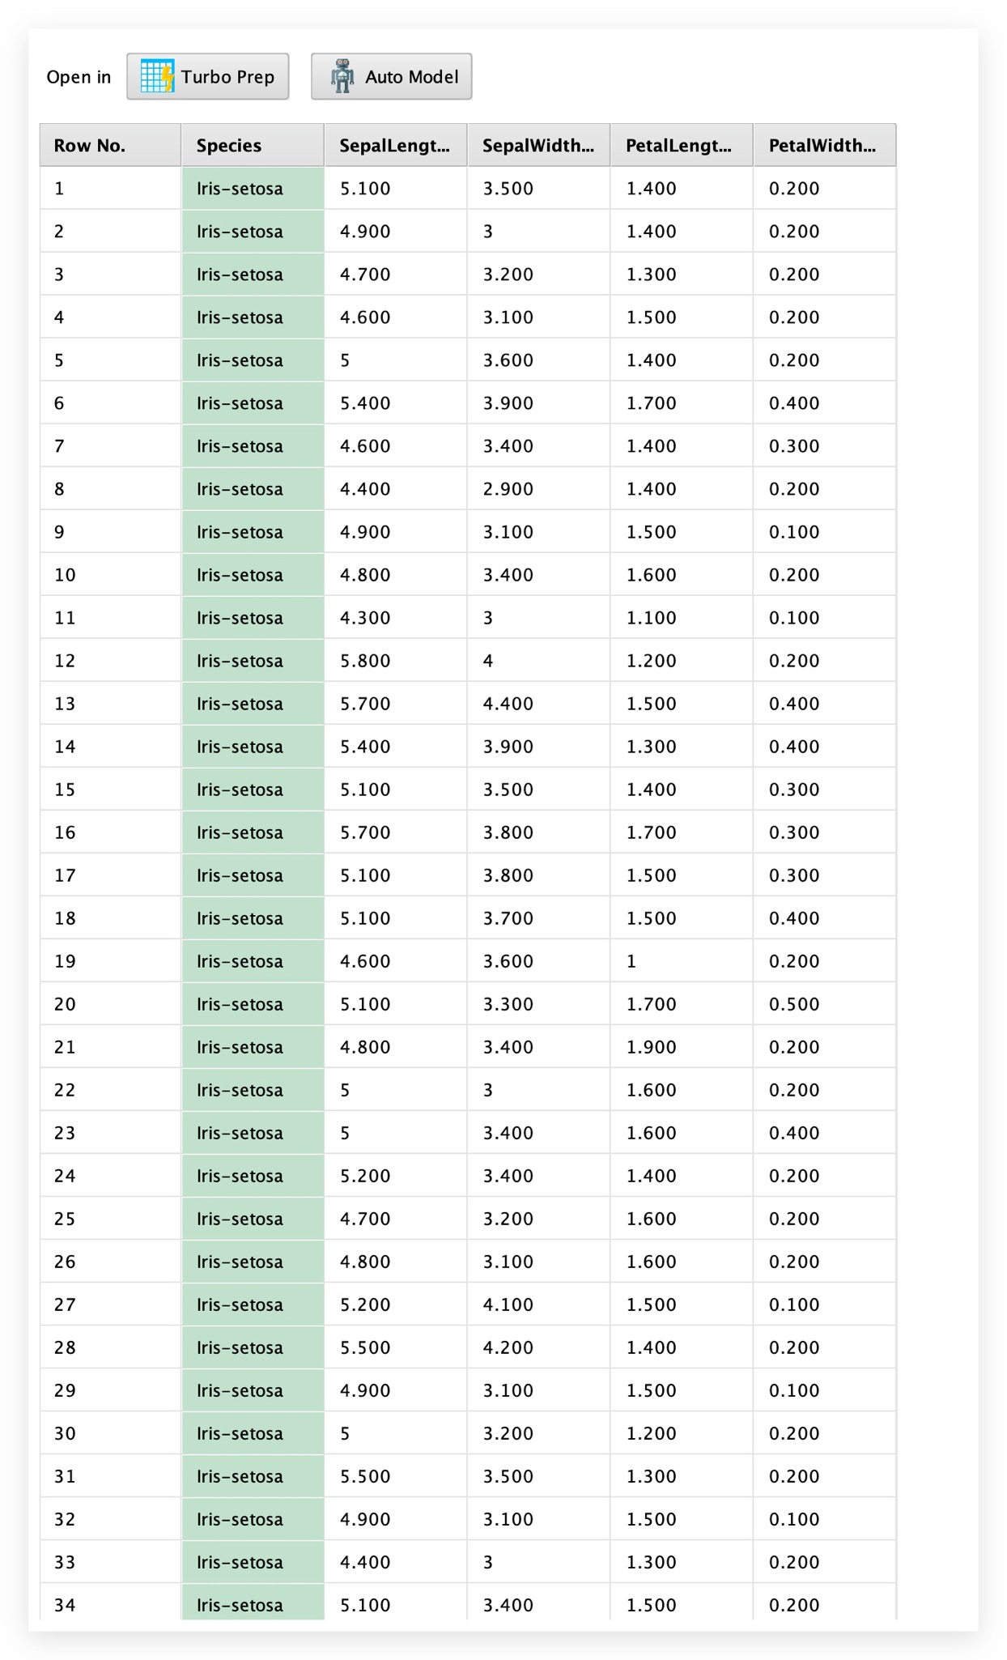After we specified it, our dataset should be appear as this.

And then we split the data by 0.7 / 0.3 ratio with the split data node to train and test the model afterwards.

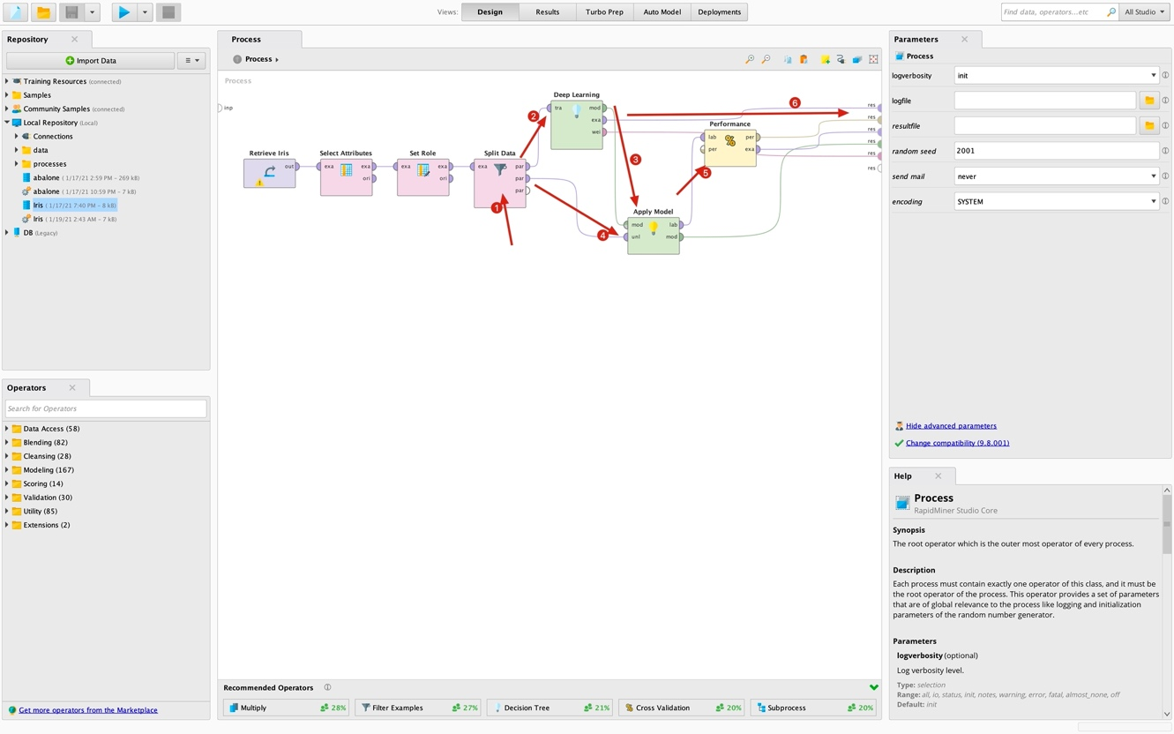After, we placed the performance node to output of the apply model node. We are ready to run our model on iris data.

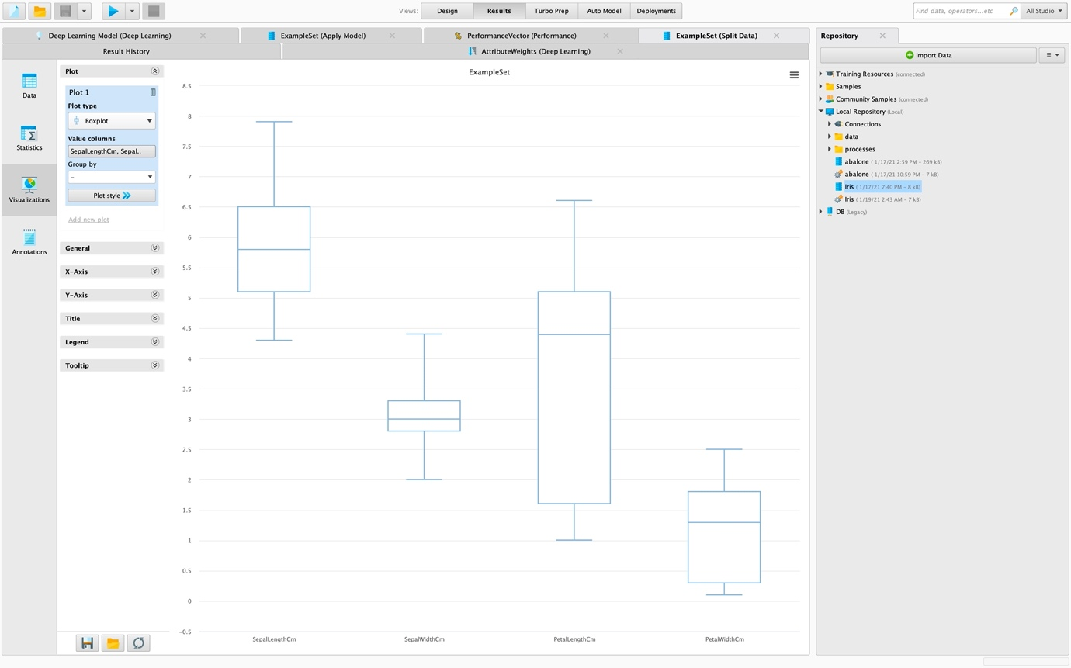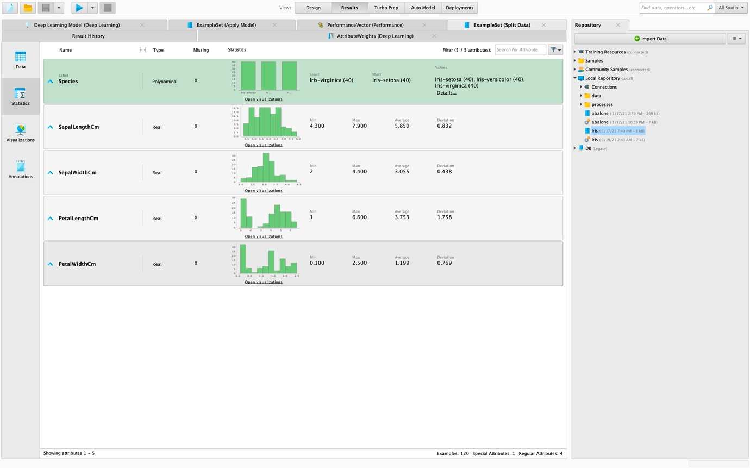To get some graphics and statistical data we need to click Visualizations section or Statistics section shown on the left in picture 3.

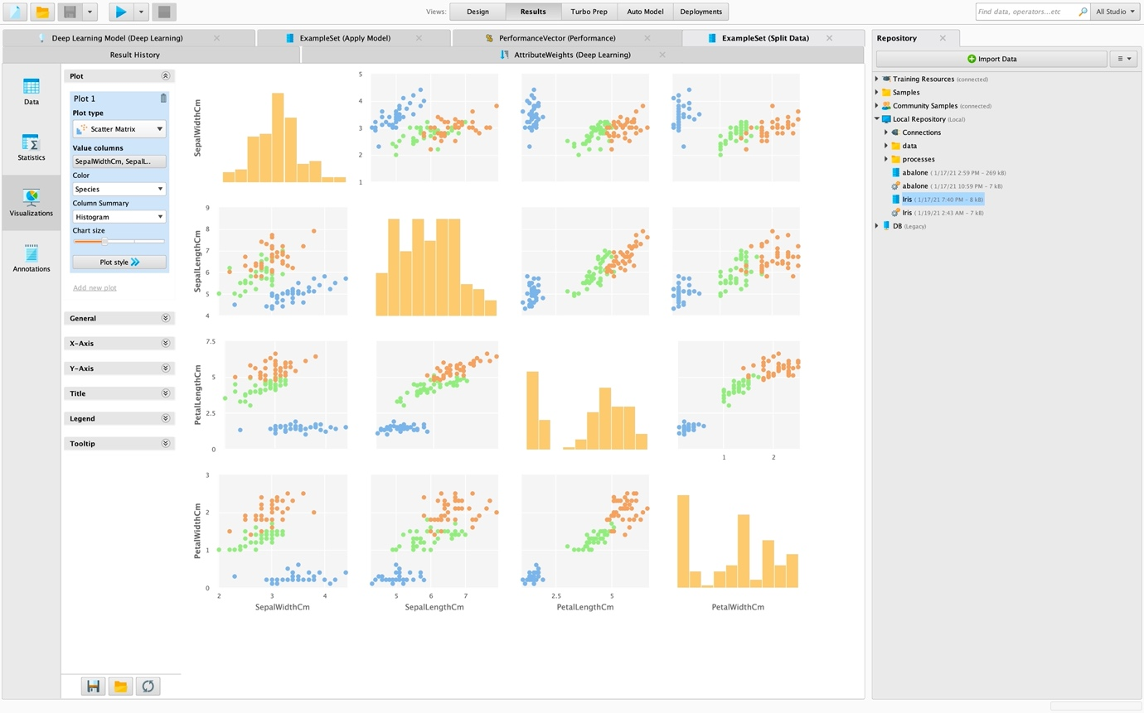

1. CODES

I strongly suggest that check out the code on

<https://github.com/tolgaberk/iris_data_mining>

First of all, let’s get some basic statistics and [Graphics](http://tolgadatamining.surge.sh/)

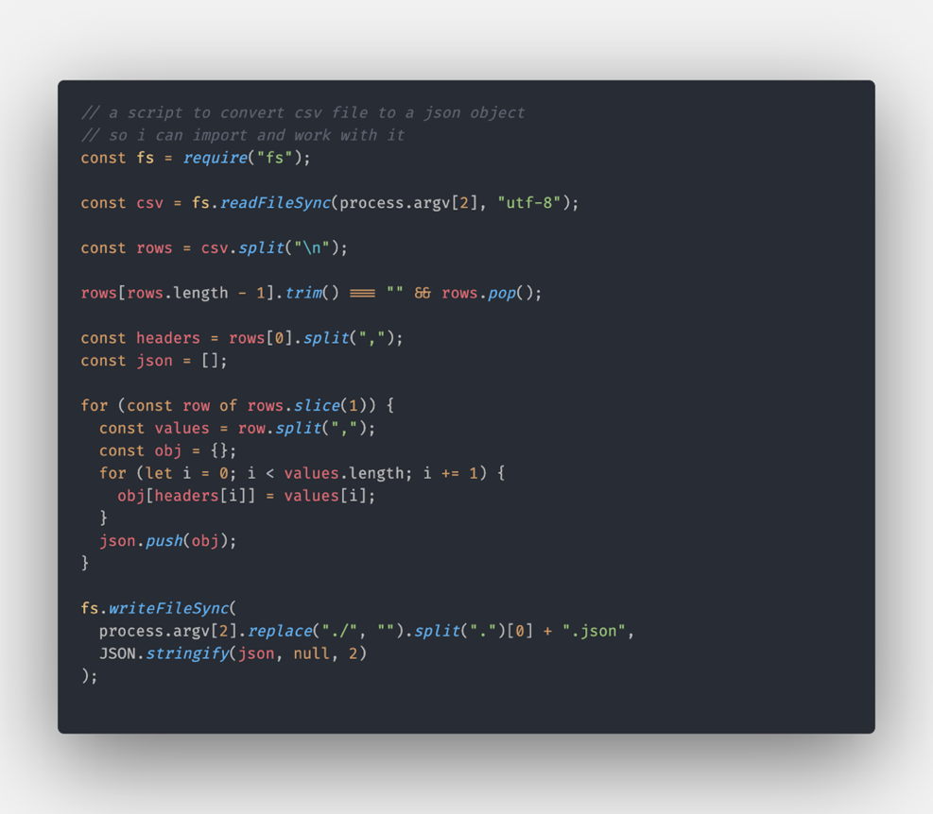

And output is like:

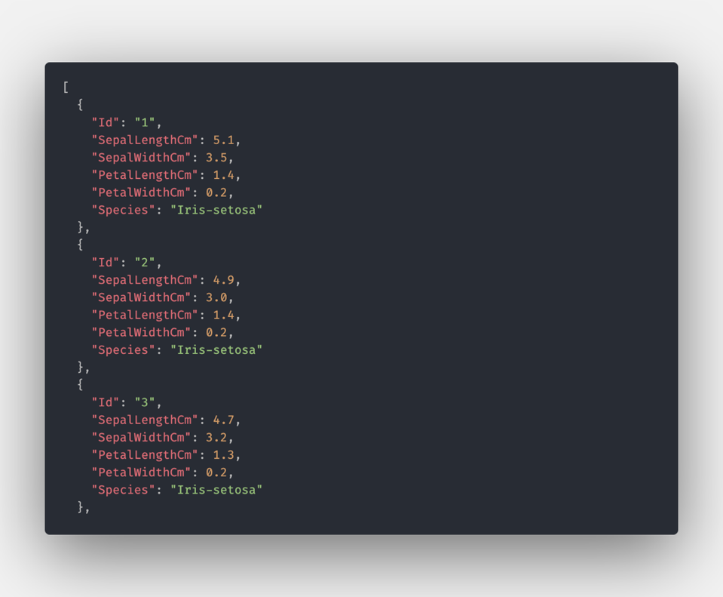

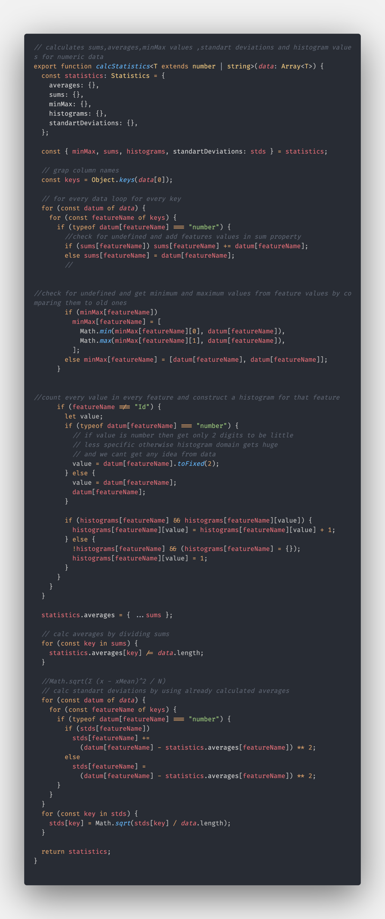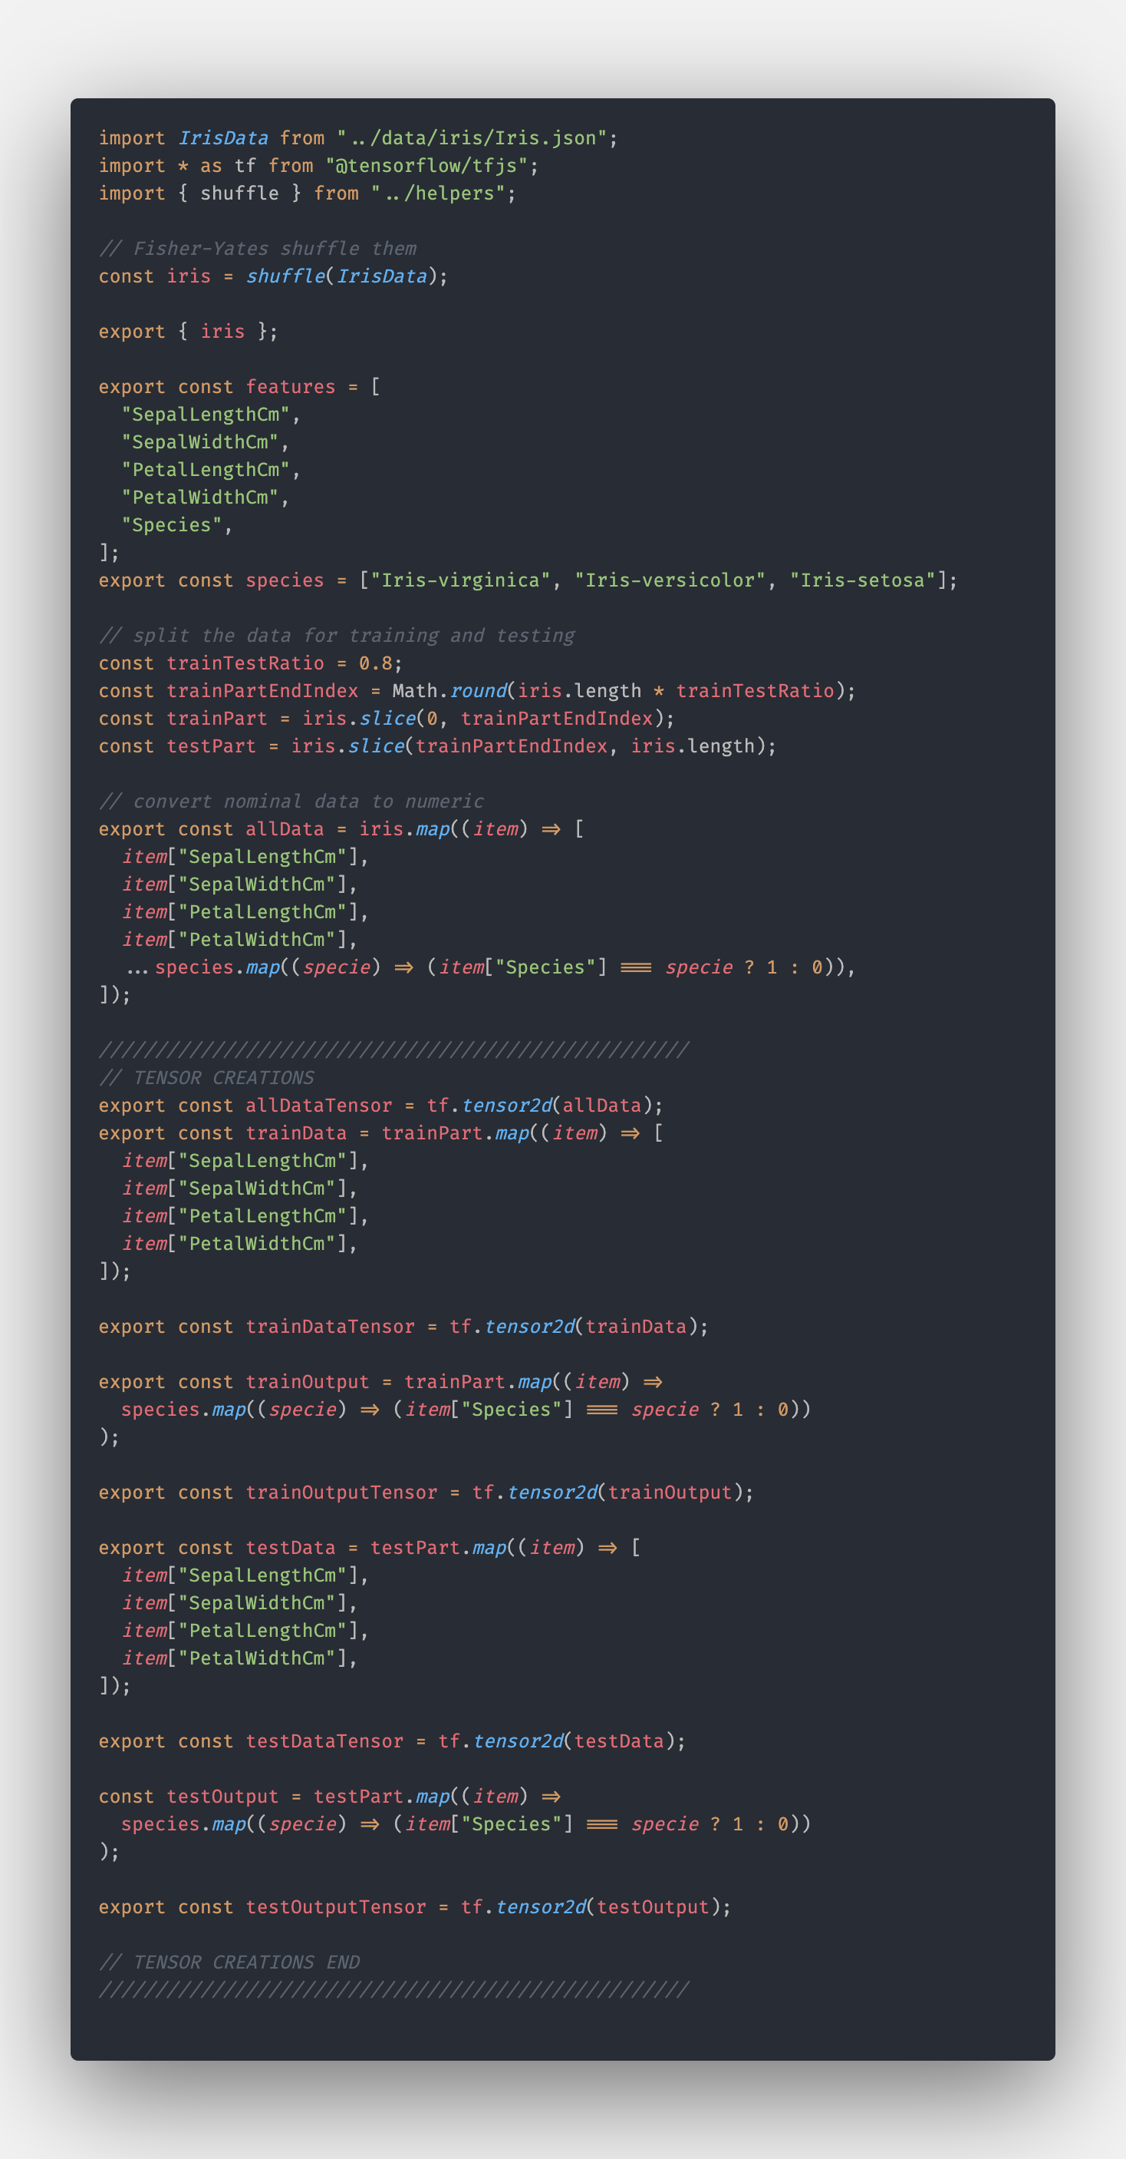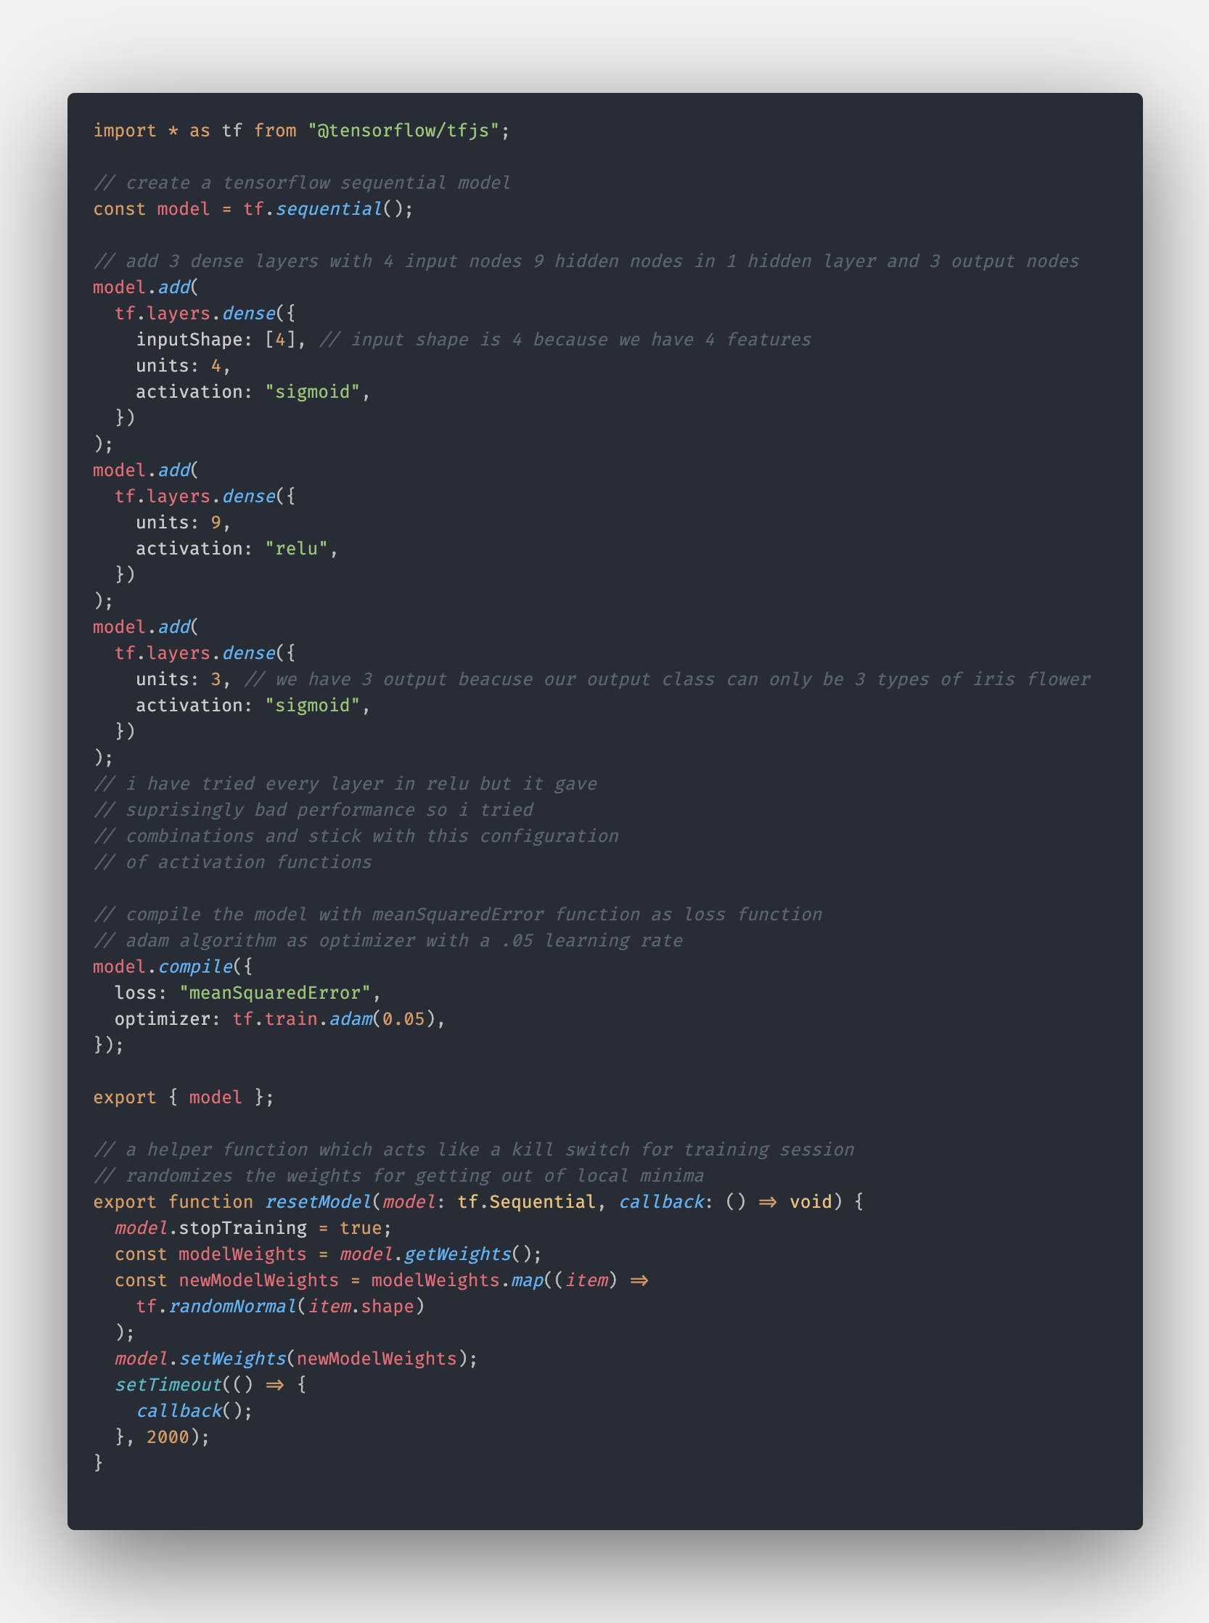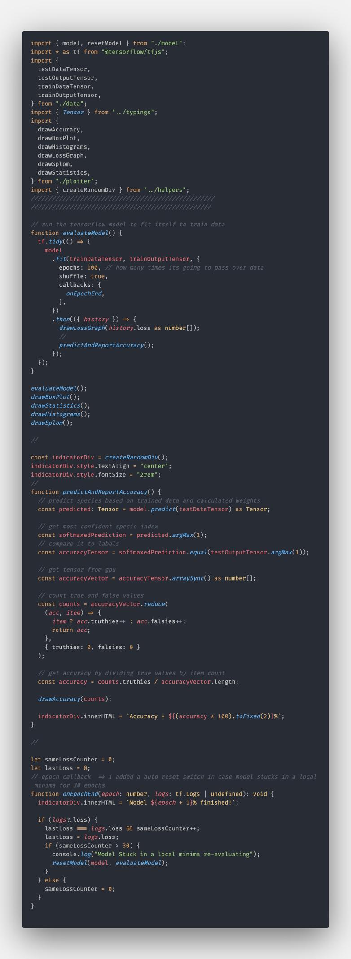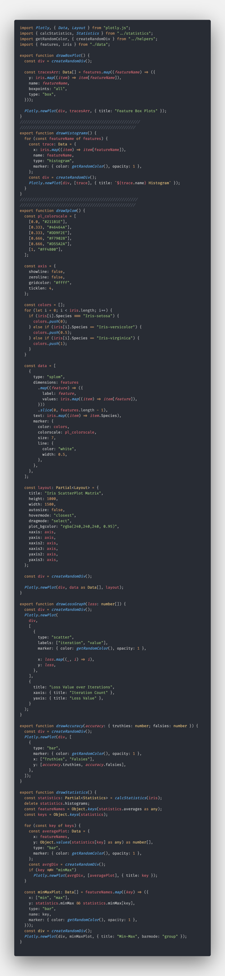

1. RESULTS

Results in RapidMiner :

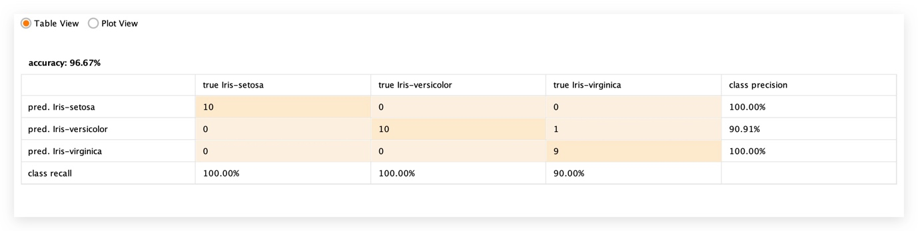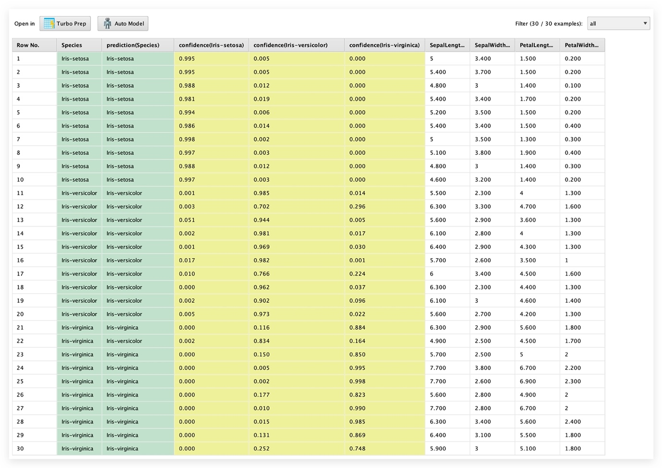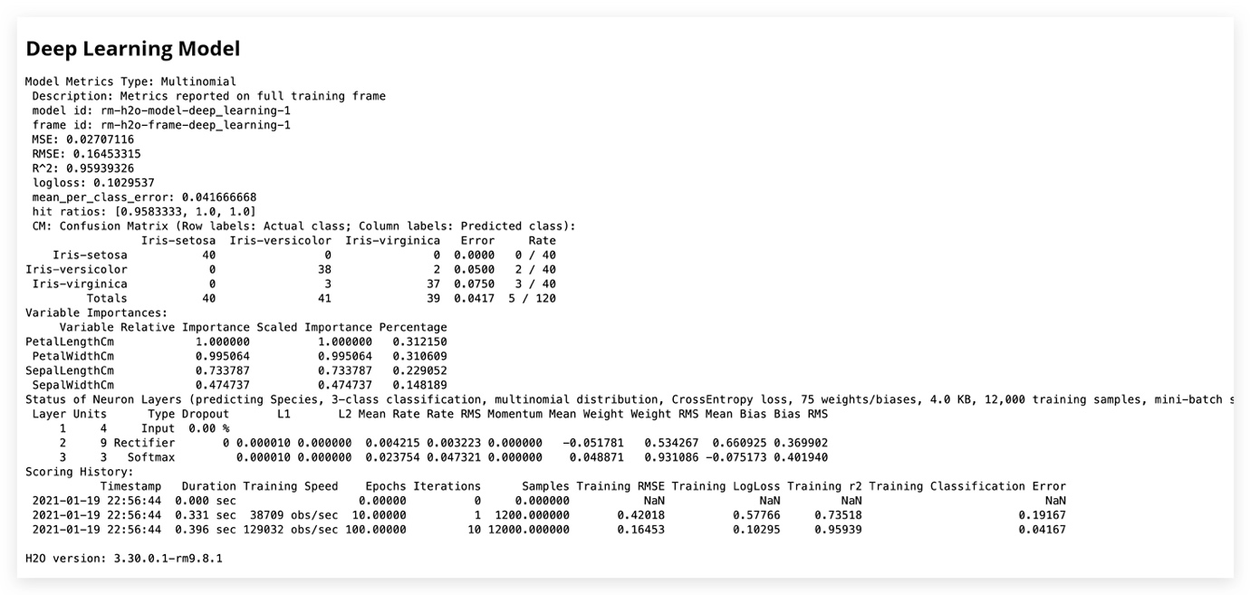

Results in my model :

[See Live](http://tolgadatamining.surge.sh/)

1. DISCUSSION AND CONCLUSIONS

The goal was to classify iris flowers into three types with four features. With only 150 sample data we accomplished that. And we are achieved more than 90 percent accuracy about correctly classifying the data given to us. We followed two approaches, one of is using a tool to abstract the logic behind and just analyzing the data and predicting results with the tool. And other was using fairly low-level coding and touching the surfaces of algorithms a little bit. Second one was a good experience for me. Rapid Miner doesn’t give you too much space to tinker with algorithms and methods. And it has certain ways to do things which is good for the industrial use case. On the other hand, with TensorFlow or any other machine learning and data analysis library we can do so many things as we want.

REFERENCES

<http://archive.ics.uci.edu/ml/datasets/Iris>

<https://www.tensorflow.org/js>

<https://plotly.com/javascript/>

<https://rapidminer.com/>

<https://www.kaggle.com/uciml/iris>

<https://www.kaggle.com/antmarakis/another-neural-network-from-scratch>

<https://bost.ocks.org/mike/shuffle/>

CHECKLIST

|  |  |
| --- | --- |
|  | YES / NO |
| Did you prepare your study both using a tool and writing code? | yes |
| Did you prepare your report as mentioned in the template? | yes |
| Did you add the results (print screen) of your study to the report? | yes |
| Did you rename your report file as asked in the template? | yes |
| Are you uploading the report to the system? | yes |
| Are you uploading the codes to the system? | yes |